Algemene fouten

# website

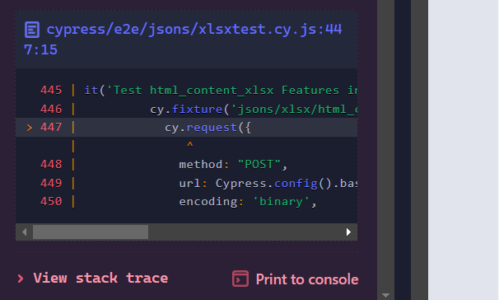

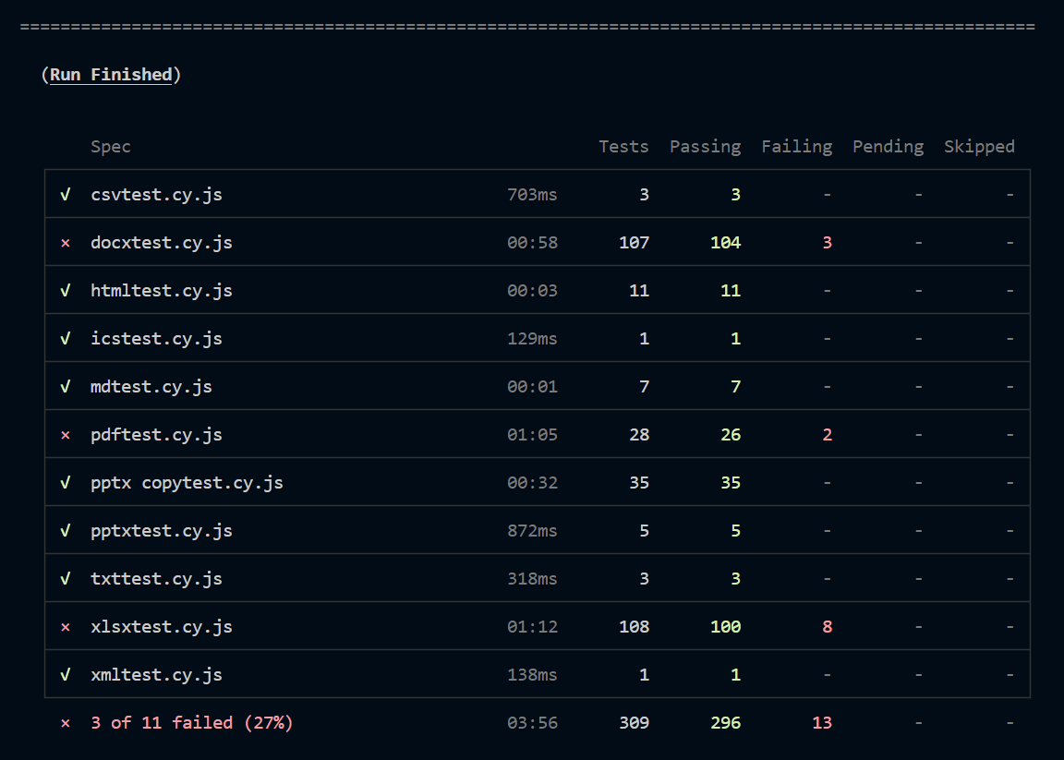

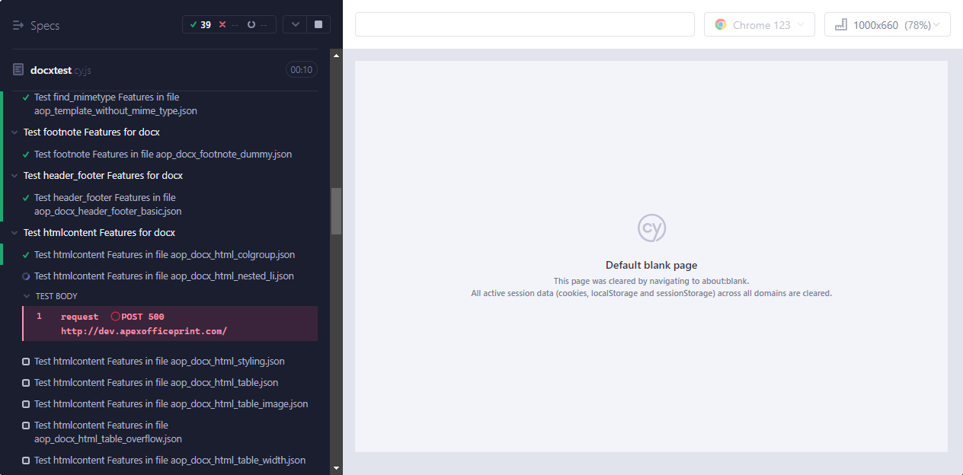

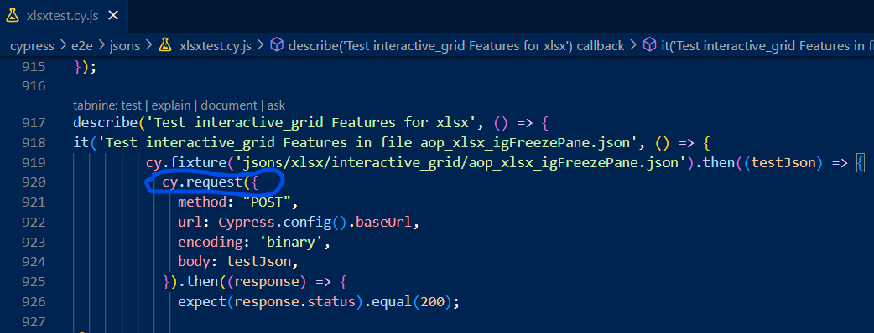

internal server error

## Soms bij het laden van de online demo op <https://www.apexofficeedit.com> loopt er een fout

Door op ok te drukken bij de foutmelding gebeurt er niks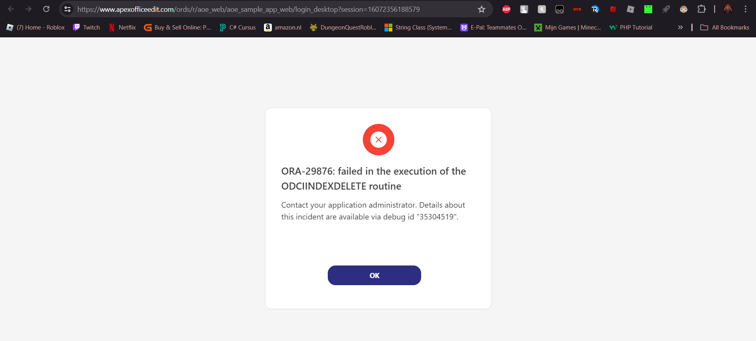

Dit is hoe het eruit zou moeten zien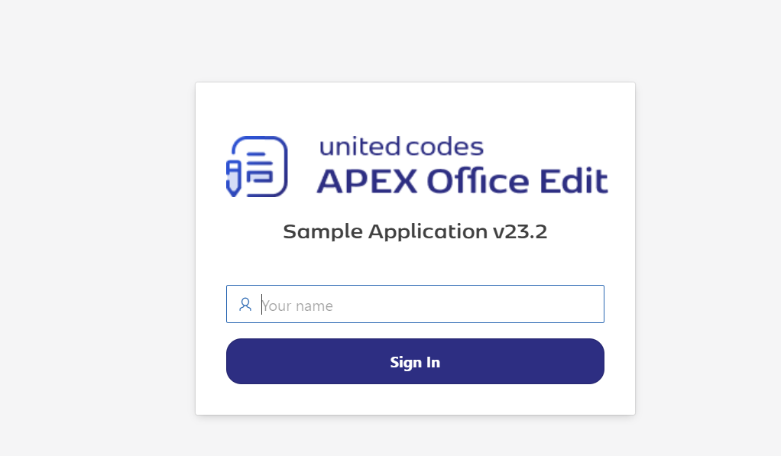

## Geen goede scaling op gsm met youtube video’s op de [ApexOfficePrint.com](http://apexofficeprint.com/) website.

[Video Quick Start Guide | APEX Office Print (AOP)](https://www.apexofficeprint.com/docs/getting-started/quick-start-video/)

## De video blijft spelen nadat je wegklikt.

<https://drive.google.com/file/d/1I9_kHqWt6PbCpSlGwa2HJdEu1GlagBFI/view?usp=sharing>

### 

### 

## Niet goede scaling op gsm bij het formulier om gegevens in te vullen.

De website voelt hierdoor “claustrofobisch” aan.

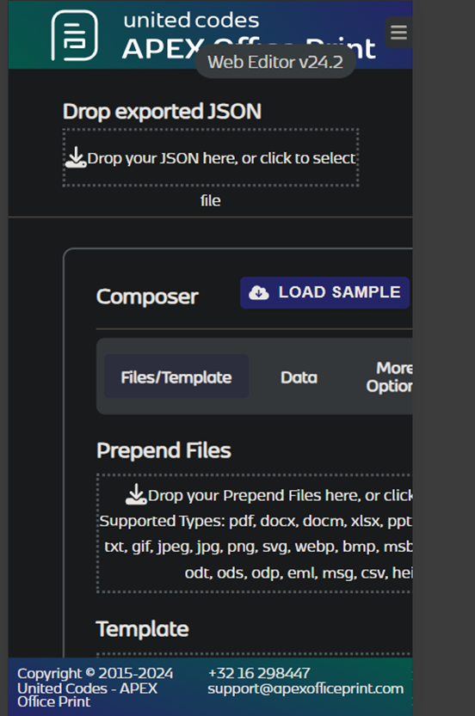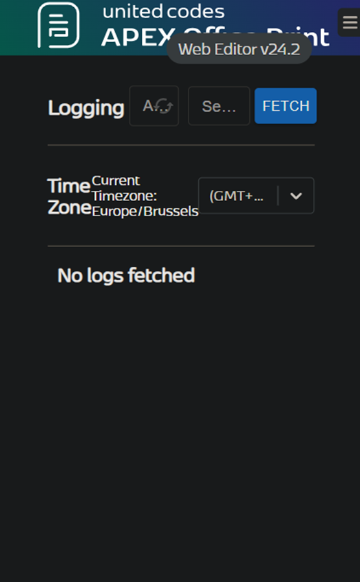

## Op AOE zijn er fouten waarbij op sommige devices een filmpje niet laad, of dat je het filmpje niet kan vergroten

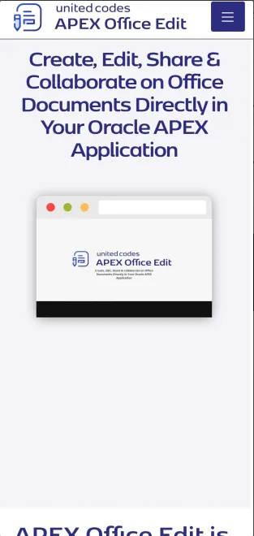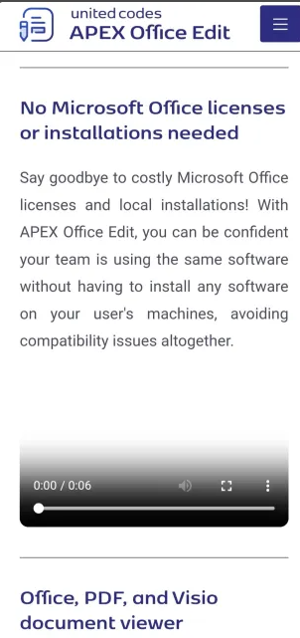

## Als je ingelogd bent en de portal sidebar opent gaat dit over de sociale media links en de support pagina, dit is enkel het geval voor APE (APEX Project Eye) en COP (Cloud Office Print)

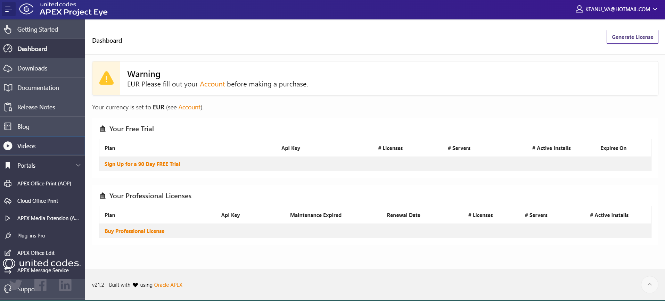

## Op de edit website bij videos op gsm verschijnt soms de row count en soms ook niet, dan moet je naar beneden scrollen om deze weer te zien: <https://www.apexofficeedit.com/ords/uc/r/uc_portal/video-library?p166_product=AOE>

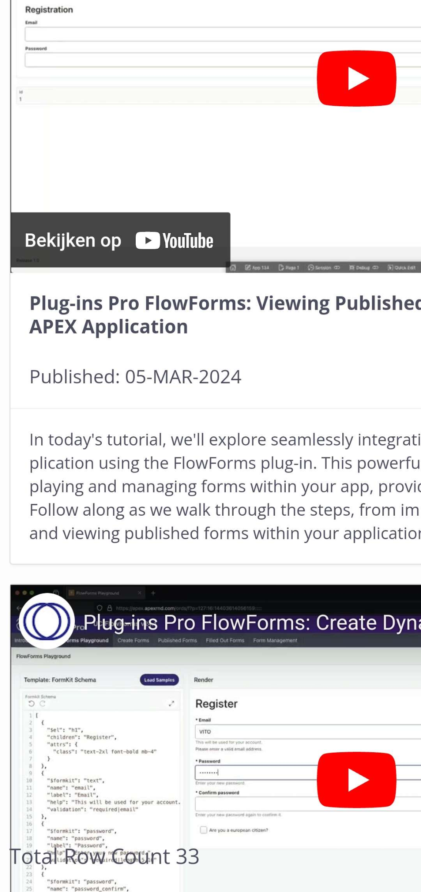

## Slechte scaling op gsm bij de blogs met code

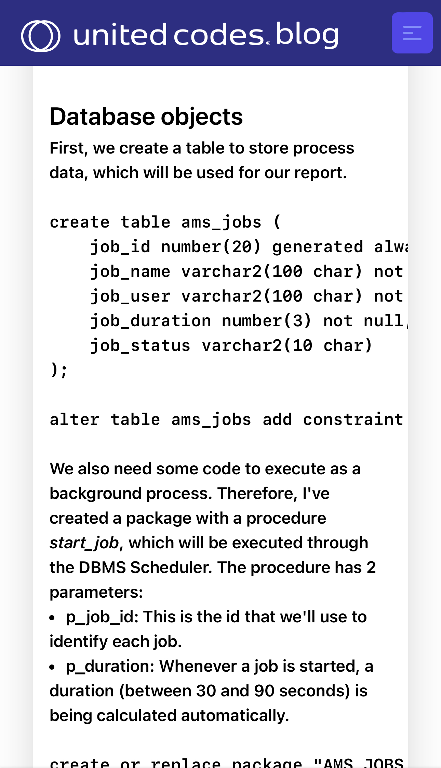

## Wanneer je een Excel bestand omzet naar een pdf wordt de gegevens in 2 gesplitst met het 2de deel op een andere pagina

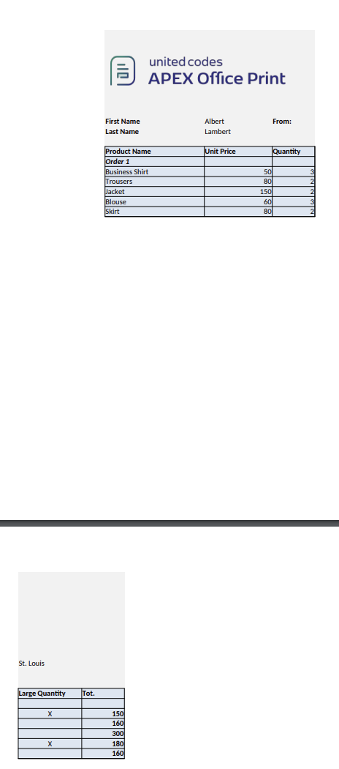

## De github link bij de apex messaging service werkt niet, dit brengt een foutmelding op

# suggesties

## United Codes: Custom HTML Template

{client_name}

{region}

{practice}

{number_of_clients}

{#resources}

{flg_client_submitted}

{purchase_approved_by}

{/resources}

{SUPPLIERS}

The tag: {client_name} will be replaced with Cus_32994

The tag: {region} will be replaced with Asia-Pacific and ...

The tag: {practice} will be replaced with Facilities

The tag: {number_of_clients} will be replaced with 3000

{#resources}: this tag starts a loop over the array of resources, we will use the first element of the array to show the available tags.

The tag: {flg_client_submitted} will be replaced with N/A

The tag: {purchase_approved_by} will be replaced with University B

The tag: {SUPPLIERS} will be replaced with…

| condition | explanation |
| --- | --- |
| {%imagekey} | If a key has base64 encoded image on it then {%imagekey} tag can be used to display the image. |
| {#resources} | This tag starts a loop over the array 'resources'. |
| {/resources} | Ending tag for looping over array resources: |
| {currency == 'EUR' ? '€' + price : '$' + price} | prints €50 if true, $50 if false, and the given price variable is 50. |
| {#flg_client_submitted=='N/A'} | If flg_client_submitted matches 'N/A', this block is printed. |
| == , <, > , <=, >=, != . | is equal to, smaller than, larger than, is smaller or equal to, is bigger or equal to, isn’t equal to |
| {number_of_clients+number_of_clients} | The result of the mathematical expression number_of_clients + number_of_clients |
| {#number_of_clients==3000} | If number_of_clients equals 3000, this block is printed. |
| {#practice=='Facilities'} | If practice matches 'Facilities', this block is printed. |
| {#region=='Asia-Pacific and ...'} | This block is printed if the region matches 'Asia-Pacific and ...'. |
| {^boolean} | This block is printed if the boolean value is false. |
| {#boolean} | This block is printed if the boolean value is true. |
| {#client_name=='Cus_32994'} | If client_name matches 'Cus_32994', this block is printed. |

Barcode and QR Codes

QR codes and barcodes can be inserted for a value of a given key by {|barcodekey} tag. The type of QR code or barcode should be specified by 'barcodekey_type' in the JSON file. Eg:

If you want to insert a QR code for a value of key 'link' then the 'link_type' key should have 'qrcode' as value. The available types are:

* Codabar  
  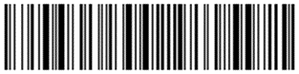
* code128  
  
* code39  
   
* ean13  
  
* upc-a  
  
* upc-e  
  
* qrcode  
  

Extra information can be given by the following tags:

| Condition | default | Explanation |
| --- | --- | --- |
| 'key_height' | 200 for the QR code, 50 for the rest. | contains the height of the barcode/QR code to be generated. |
| 'key_width' | 200 | contains the width of the barcode/qrcode to be generated. |
| 'key_version' | 4 | contains the version of the QR code to be used. |
| 'key_errorcorrectlevel' | 'M' | contains the level at which the QR code should be recoverable ('L', 'M', 'Q', or 'H'). |
| 'key_cellsize' | / | contains the dot size of a module inside the QR code |

# testen

# resultaat van all de testen

gegeven foutmeldingen 